A)
1)
Prediction result shows Linear model wins out of all 3 since data was linear

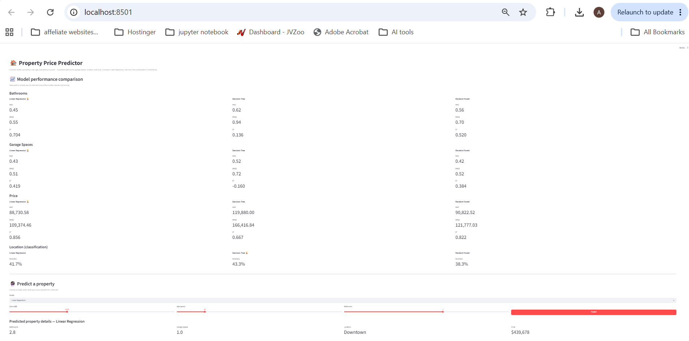
2)
Prediction result shows Linear model wins out of all 3
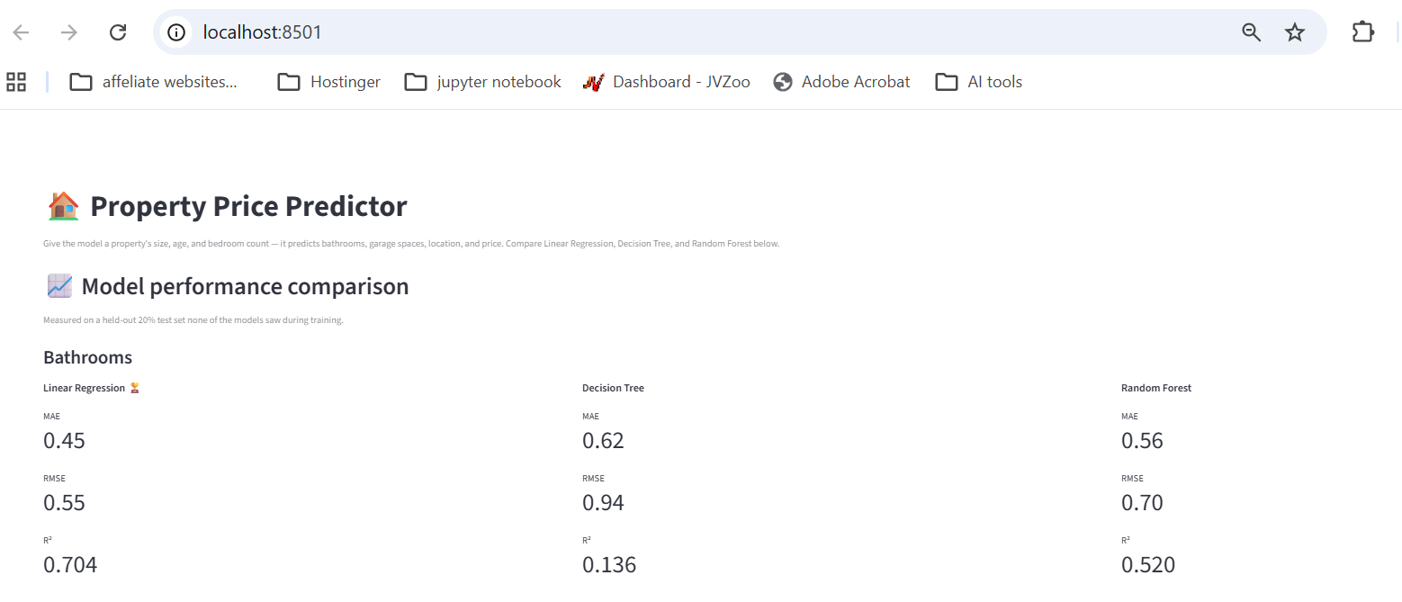
3)
We can provide input and predict property price from any of 3 models.
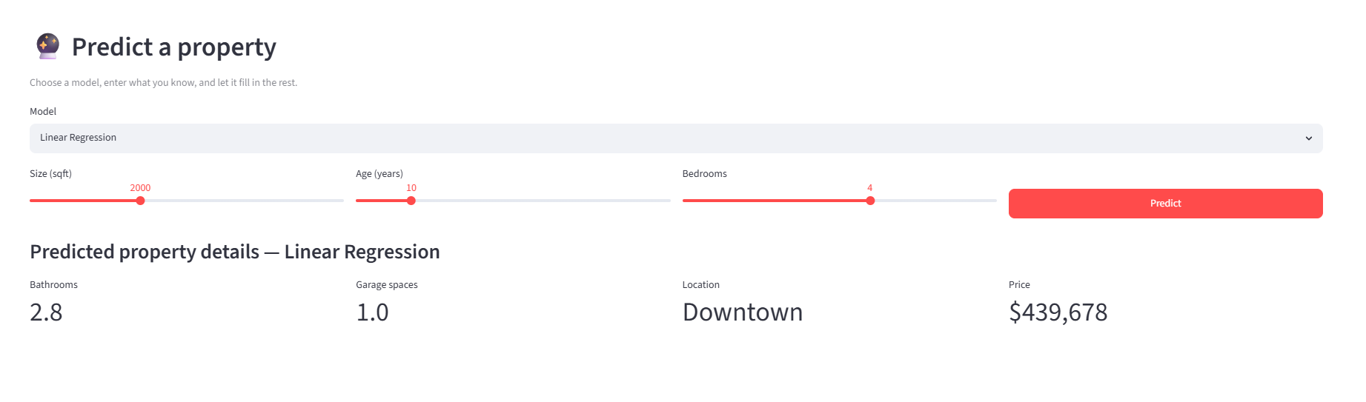

B)
1)
Prediction result shows Random forest model wins out of all 3 since data is non linear

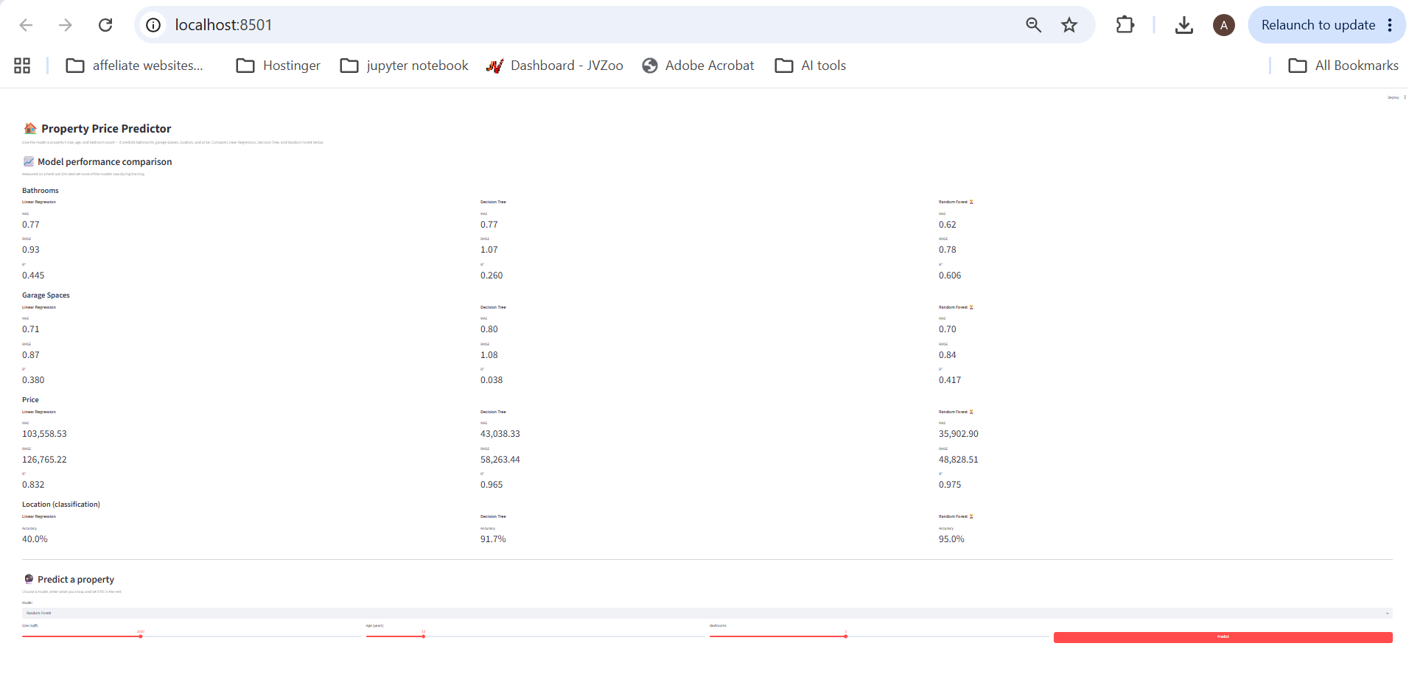
2)
Prediction result shows Random forest model wins out of all 3 since data is non linear
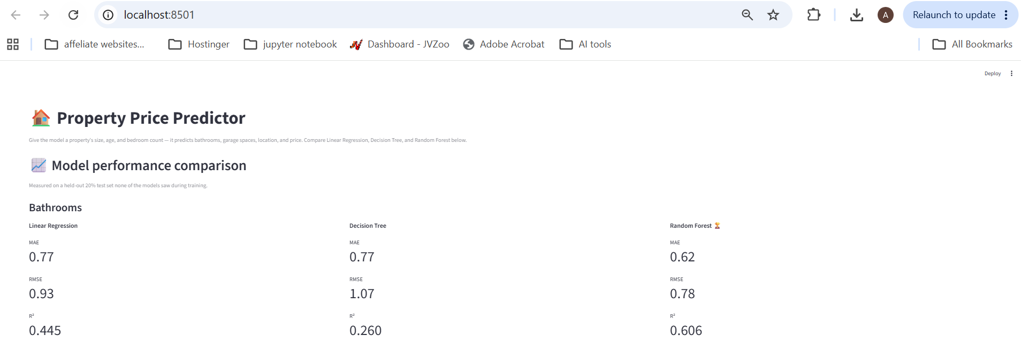

3)
We can provide input and predict property price from any of 3 models.
